Market Microstructure — Trading & Market Mechanics
How Orders Become Trades, and Why the Screen Price Is Not the Trade Price
From the Limit Order Book to Optimal Execution: Understanding How Markets Actually Work
A Level 2 module in the Quantitative Finance Curriculum — revisited at Level 5
Covers: order books · bid-ask spread · market/limit orders · order types · market depth · liquidity · price discovery · order flow · trade direction · market impact · slippage · transaction costs · adverse selection · information asymmetry · maker-taker dynamics · queue position · order-book imbalance · VWAP/TWAP · execution algorithms · auction mechanisms · high-frequency trading · latency · microstructure noise · optimal execution

Table of Contents
How to Use This Guide
What You Need to Know Before Starting
Understand Before Proceeding
Why It Matters
How This Connects to the Rest of the Curriculum
Glossary of Recurring Terms
Part 1 — The Order Book and Price Formation
1.1 Order Types and Order-Book Structure
1.2 The Bid-Ask Spread, Depth, and Liquidity
1.3 Price Discovery and Order Flow
Part 2 — The Cost of Trading
2.1 Transaction Costs and Slippage
2.2 Market Impact
2.3 Trade Direction and Order-Flow Toxicity
Part 3 — Information and Order-Book Signals
3.1 Adverse Selection and Information Asymmetry
3.2 Maker-Taker Dynamics and Queue Position
3.3 Order-Book Imbalance
Part 4 — Execution Algorithms and Benchmarks
4.1 VWAP and TWAP
4.2 Execution Algorithms and Optimal Execution
4.3 Auction Mechanisms
Part 5 — High-Frequency Trading and Market Quality
5.1 High-Frequency Trading
5.2 Latency and the Race to Zero
5.3 Microstructure Noise
Part 6 — From Signal to Executable Strategy
6.1 Translating a Signal Into a Realistic Trade
6.2 Building and Monitoring Execution Infrastructure
Practical Exercise
Common Beginner Mistakes
Advanced Extensions
Professional Applications
Where to Go Next

How to Use This Guide
This document is a companion to Market Microstructure — Trading & Market Mechanics, the module that explains how a trading intention actually becomes a trade, and how much of a theoretical edge survives that process. Every other module in this curriculum implicitly assumes trades happen at a known price with no friction. This module removes that assumption: it examines the order book, the mechanics of order types, the cost of demanding liquidity, and the algorithms built to execute large trades without giving away the strategy's edge in the process.
The module is self-contained: every concept is introduced from first principles, paired with a worked numerical example, and illustrated with a chart or diagram wherever a picture makes the idea land faster than prose. Read it start to finish if microstructure is new to you, or jump straight to the section you need — but do not skip Understand Before Proceeding below.

What You Need to Know Before Starting
- Probability & Statistics — random variables and basic distributional reasoning, since order flow and price changes are treated statistically throughout.
- Time-Series Analysis — the idea of serially dependent data, since quotes, trades and order-book updates arrive as a dependent, irregularly spaced sequence.
- Risk Metrics — volatility and basic risk measurement, since execution cost is one more source of risk that has to be measured and controlled, not assumed away.
- Derivatives — enough familiarity with how instruments trade to follow quoting and hedging examples drawn from options and futures markets.
- Basic Optimisation — the idea of minimising a cost function subject to constraints, which is the backbone of optimal execution.
- Returns & Portfolio Mathematics — how a raw price return differs from a realised, cost-adjusted return, which is exactly the gap this module explains.

Understand Before Proceeding
Prerequisite gate — The price on the screen is not the price at which meaningful size can be traded.
Execution depends on available liquidity, order-book depth, queue position, order type, prevailing market conditions and the strategy's own market impact. Everything in this module is deliberately at awareness depth for the harder quantitative topics (stochastic order-book models, Hawkes processes, Kyle's lambda, Glosten-Milgrom models, Almgren-Chriss optimal execution) — enough to reason correctly about why naive execution assumptions overstate performance, but not enough to safely build production execution or market-making systems. That requires the Depth 3+ treatment of this same material, referenced in Advanced Extensions.

Why It Matters
A trading strategy can look highly profitable on a chart of theoretical positions and still lose money once it is actually implemented. Between a model's signal and a filled order sits a chain of frictions: the bid-ask spread that must be crossed or captured, the market impact of demanding size the order book does not currently hold, the slippage that accumulates while an order works, and the risk that faster or better-informed participants trade against the order before it completes. None of these frictions are visible in a naive backtest that assumes trades occur at the last traded or closing price.
The practical stakes compound with strategy speed and size. A slow-turnover strategy trading modest size relative to average volume may tolerate simplistic execution assumptions reasonably well; a high-turnover strategy, or one trading a meaningful fraction of daily volume, can see its entire theoretical edge consumed by transaction costs before it ever reaches the bottom line. Understanding microstructure is what allows a signal, however good, to survive contact with a real market.

How This Connects to the Rest of the Curriculum
- Research — Microstructure provides the foundation for order-flow signals, bid-ask spread modelling, liquidity forecasting, order-book imbalance research, short-horizon price prediction and market-impact modelling — an entire category of signal that exists nowhere else in the curriculum.
- Development — Market-data and execution systems must correctly process timestamps, trades, quotes, order-book updates and cancellations, in the correct sequence and at the correct precision. Getting event ordering wrong silently corrupts every backtest and every live signal built on top of it.
- Trading — Microstructure directly affects quoting, execution, hedging and inventory management. Traders monitor spreads, depth, order flow, liquidity and market impact continuously to decide how, where and how fast an order should be executed.

Glossary of Recurring Terms
Order book — The continuously updated ledger of outstanding limit orders to buy and sell a security, organised by price and, within each price, by time of arrival.
Limit order — An order to buy or sell at a specified price or better; it rests in the order book until it is filled, cancelled, or expires, and provides liquidity while it waits.
Market order — An order to buy or sell immediately at the best currently available price(s); it takes liquidity from the book and guarantees execution but not a specific price.
Market depth — The quantity of shares or contracts available to trade at and near the best bid and ask prices — a measure of how much size the book can absorb before price moves.
Liquidity — The ease with which an asset can be traded in size without moving its price; a multidimensional property combining spread tightness, depth, and how quickly the book replenishes after a trade.
Bid-ask spread — The difference between the best (highest) price a buyer is currently willing to pay and the best (lowest) price a seller is currently willing to accept.
Price discovery — The ongoing process by which trading activity causes a security's price to converge toward a value reflecting all currently available information.
Order flow — The sequence of incoming orders, and particularly of executed trades classified as buyer-initiated or seller-initiated, arriving at a market over time.
Market impact — The extent to which a trade itself moves the price of the security being traded, separate from any change in the security's underlying value.
Slippage — The difference between the price expected at the time a trading decision was made and the price actually achieved once the order is executed.
Adverse selection — The risk a liquidity provider bears that a resting order will be filled disproportionately by better-informed counterparties, at prices that later prove unfavourable.
Information asymmetry — A situation in which one party to a potential trade has more or better information than the other about the security's true value.
Maker-taker — An exchange fee model that pays a rebate to orders that add ("make") liquidity to the book and charges a fee to orders that remove ("take") it.
Queue position — A resting limit order's place in line, relative to other orders at the same price, under price-time priority — earlier orders at a price are filled first.
Order-book imbalance — A measure of the relative size of resting buy versus sell interest near the top of the book, often used as a short-horizon directional signal.
VWAP — Volume-weighted average price — the average price of all trades in a security over a period, weighted by the volume of each trade; a common execution benchmark.
TWAP — Time-weighted average price — the average price sampled at even intervals over a period, independent of how much volume traded at each point; a simpler execution benchmark than VWAP.
Latency — The time delay between an event occurring in a market (such as a price update) and a participant being able to observe it and react.
Microstructure noise — The deviation of observed transaction prices from an underlying, unobservable "efficient" price, arising from discreteness, bid-ask bounce, and other trading frictions.

Part 1 — The Order Book and Price Formation
Every trade in an electronic market begins with the order book: the continuously updated ledger of every outstanding intention to buy or sell. This part introduces its structure, the vocabulary of order types built on top of it, and price discovery — the process by which the interaction of resting and incoming orders determines what a security is actually worth at any instant.

1.1 Order Types and Order-Book Structure
An order book has two sides: a bid side listing resting buy orders, ranked from highest to lowest price, and an ask (or offer) side listing resting sell orders, ranked from lowest to highest price. Orders at the same price are typically ranked by time of arrival — price-time priority — so that the first order to arrive at a given price is the first to be filled when a matching order arrives.
A limit order specifies a price or better and rests in the book, adding liquidity, until it is filled, cancelled, or expires. A market order specifies only a quantity and executes immediately against the best available resting orders, taking liquidity from the book and walking through successive price levels if its size exceeds what is available at the best price. Beyond these two basics, real markets support a range of order types built for specific purposes: stop orders that convert to market or limit orders once a trigger price is reached, iceberg (or hidden/reserve) orders that display only a fraction of their true size, pegged orders that automatically track a reference price such as the midpoint, and time-in-force instructions such as immediate-or-cancel (IOC) or fill-or-kill (FOK) that control how long an order is allowed to rest.
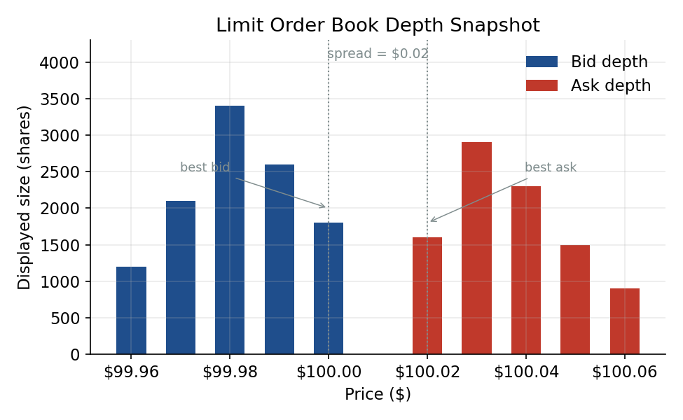
Figure 1.1 — A snapshot of a limit order book: resting bid depth on the left, resting ask depth on the right, separated by the bid-ask spread.
Common mistake — Treating a market order as free of cost.
A market order guarantees execution but not price: it walks the book, consuming resting liquidity from the best price outward, so an order large enough to exhaust several price levels pays materially worse than the quoted best price — an effect distinct from, and additive to, the bid-ask spread itself.

1.2 The Bid-Ask Spread, Depth, and Liquidity
The bid-ask spread is the difference between the best (highest) bid and the best (lowest) ask; the mid-price, their average, is a convenient reference point but is not itself a price at which anyone can actually trade. Market depth describes how much size sits at and near the best prices — a thin book can be moved by a modest order, while a deep one can absorb considerable size before price responds. Together, spread, depth, and how quickly a book replenishes after being traded through (its resiliency) make up what practitioners mean by liquidity.
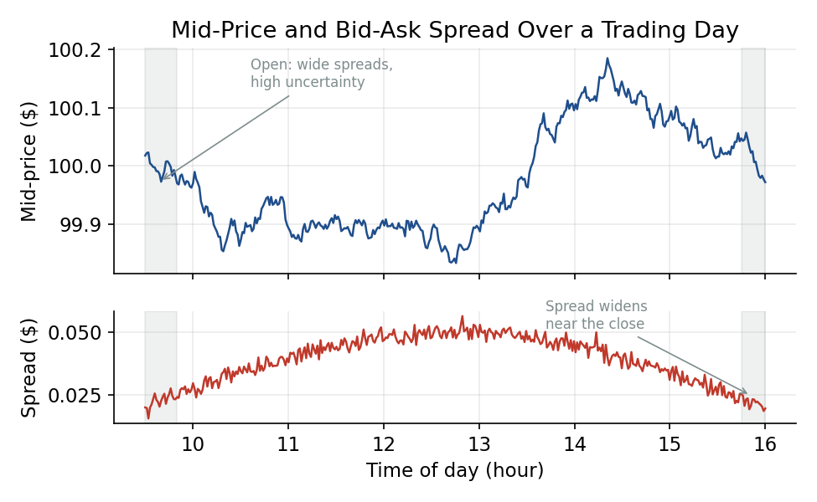
Figure 1.2 — Mid-price and bid-ask spread over a single trading day: spreads are typically wider at the open, when uncertainty about the day's opening price is highest, and can widen again into the close.
Worked example — Why the mid-price is not executable.
A stock quotes $100.00 bid / $100.02 ask. The mid-price is $100.01, but no resting order exists there: a market buy order executes at $100.02 or worse, and a market sell order executes at $100.00 or worse. A backtest that fills trades at the mid-price, or at the last traded price, is implicitly assuming access to a price that was never actually available — overstating profitability by roughly the half-spread on every round trip, before any consideration of size.

Tip — Liquidity is not one number.
Tightness (how narrow the spread is), depth (how much size sits at or near the best price), and resiliency (how quickly the book replenishes after a trade consumes it) can move independently. A market can have a tight spread but thin depth, or vice versa, and a strategy's realistic trading costs depend on all three, not the spread alone.

1.3 Price Discovery and Order Flow
Price discovery is the ongoing process by which trading activity causes a security's observed price to converge toward a value reflecting all currently available information. The mechanism driving this is order flow: the sequence of incoming orders and, in particular, of trades classified as buyer-initiated (an incoming buy order hit a resting ask) or seller-initiated (an incoming sell order hit a resting bid). Persistent one-sided order flow — more buyer-initiated than seller-initiated volume, or vice versa — is one of the most direct empirical signatures of information reaching the market and being traded on.
Common mistake — Assuming price changes only from new information.
Prices also move for pure order-flow and inventory reasons, with no news involved at all. A large sell order can push price down temporarily purely as compensation demanded by liquidity providers for absorbing unwanted inventory, before reverting once that inventory is unwound — a distinction Part 3 returns to under adverse selection.

Part 2 — The Cost of Trading
A trade's true cost has several components beyond the quoted spread: the cost of crossing the spread itself, the cost of moving the market while trading, and the cost from prices drifting during the time an order takes to complete. This part decomposes trading costs into these pieces, so that a theoretical strategy return can be turned into a realistic, executable one.

2.1 Transaction Costs and Slippage
Transaction costs are usually split into explicit costs — commissions, exchange fees, and taxes, which are known in advance and simple to account for — and implicit costs, which are not directly billed but are just as real: the bid-ask spread paid on each trade, the market impact caused by the trade itself, and slippage, the difference between the price expected at the moment a trading decision was made and the price actually achieved once the order is filled. A widely used framework for tallying all of this is implementation shortfall: the gap between the return of a hypothetical "paper" portfolio that transacts instantly at the decision price and the return of the portfolio actually achieved, decomposed into delay cost (price drift between decision and order submission), execution cost (spread and impact paid while trading), and opportunity cost (the cost of any portion of the order that was never filled at all).
Worked example — Pricing out a slippage cost.
A portfolio manager decides to buy 10,000 shares when the price is $50.00 (the decision price). By the time the order is fully worked, the average execution price achieved is $50.06. The slippage cost is $0.06 per share, or $600 on the order — roughly 12 basis points relative to the $500,000 notional, an amount that must be subtracted from whatever theoretical edge the trade was meant to capture before the trade's true profitability can be assessed.

2.2 Market Impact
Market impact is the extent to which a trade itself moves the price of the security being traded, independent of any genuine change in its underlying value. Impact is typically split into a temporary component, which reverts once the trade is complete and the liquidity it consumed is replenished, and a permanent component, which persists because the trade itself revealed information about supply, demand, or the trader's own beliefs. A well-documented empirical regularity — often called the square-root law of market impact — is that impact cost tends to scale roughly with the square root of order size relative to average trading volume, rather than linearly.
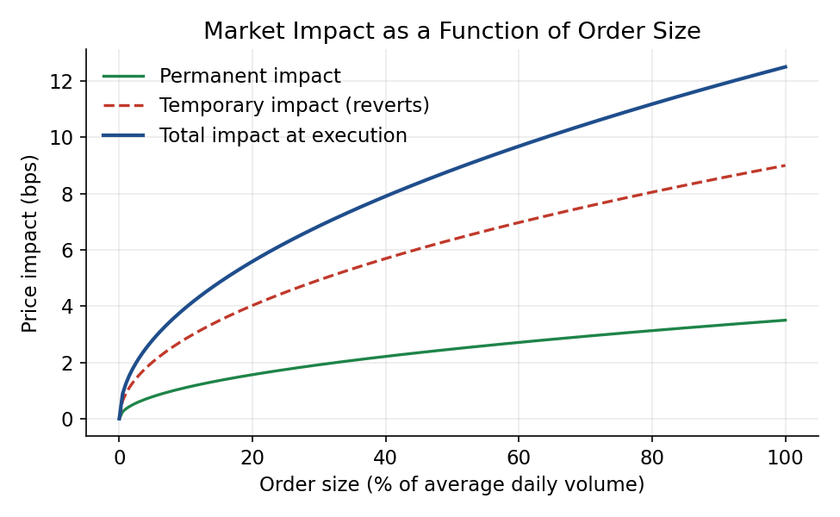
Figure 2.1 — Market impact as a function of order size, split into a permanent component (which persists) and a temporary component (which reverts once the order finishes trading).
Common mistake — Assuming market impact is linear in order size.
Because empirical impact grows roughly with the square root of size, doubling an order's size less than doubles its total cost — but the cost per share still rises with size, making one giant order considerably more expensive per share than the same total volume split into smaller pieces over time. This is exactly the motivation for the execution algorithms covered in Part 4.

Tip — Impact is partly temporary.
A meaningful fraction of price impact reverts after a trade completes, as liquidity providers unwind the inventory they absorbed. The permanent component is the piece that reflects genuine new information reaching the market; the temporary component is compensation for providing liquidity and immediacy, and is, in principle, avoidable by trading more patiently.

2.3 Trade Direction and Order-Flow Toxicity
Because market makers cannot observe why a given order arrived, they must price every trade as if it could be informed. Order flow that turns out to be highly correlated with subsequent price moves — flow that, in hindsight, mostly came from better-informed traders — is described as toxic: it costs liquidity providers money on average and, if persistent, causes them to widen spreads or withdraw liquidity altogether. Trade direction, whether a given trade was buyer- or seller-initiated, is the basic building block from which order-flow toxicity is measured; the Volume-Synchronised Probability of Informed Trading (VPIN) is one commonly cited toxicity metric, introduced here only at awareness level.
Worked example — A market maker facing mixed order flow.
A market maker quotes a two-cent spread and, over a session, fills roughly equal buyer- and seller-initiated volume from a broad mix of retail and institutional counterparties. If, on one particular day, incoming flow becomes overwhelmingly one-sided and concentrated just ahead of a scheduled announcement, the market maker faces a much higher probability that this flow is informed — and the rational response, widening the quoted spread or reducing displayed size, is precisely the mechanism by which information asymmetry (Part 3) translates into a wider observed spread.

Part 3 — Information and Order-Book Signals
Some participants trading in a market know more than others about where the price is heading. This part covers how that asymmetry shapes market-maker behaviour and pricing, the market structures — maker-taker pricing, queue position — built around continuous trading, and how the order book itself can be read for short-horizon signal.

3.1 Adverse Selection and Information Asymmetry
Adverse selection, in a microstructure context, is the risk a liquidity provider bears that a resting order will be disproportionately filled by better-informed counterparties, at prices that later prove unfavourable to the provider. A resting limit order is, in effect, a standing offer to trade with anyone who wants to — including someone who knows something the resting order's owner does not. Classic microstructure theory (the Glosten-Milgrom framework, at awareness level here) shows that this risk alone, even absent any inventory or order-processing cost, is sufficient to generate a positive bid-ask spread: market makers price in a cushion to compensate for the fraction of their flow that is informed.
Prerequisite gate — Glosten-Milgrom and Kyle's lambda are Depth 3+ topics.
At this level, the goal is to understand why information asymmetry alone can create a bid-ask spread even with zero inventory-holding cost or order-processing cost, not to derive the equilibrium spread formula or Kyle's lambda (the linear price-impact coefficient relating order flow to price change) from first principles. That derivation belongs to Depth 3+.

A direct, observable consequence is that spreads widen around scheduled information events — earnings releases, economic data, central bank announcements — precisely when the probability that incoming order flow is informed is at its highest, and narrow again once the information has been publicly revealed and the asymmetry has largely disappeared.

3.2 Maker-Taker Dynamics and Queue Position
Most electronic exchanges use a maker-taker fee model: a small rebate is paid to orders that add ("make") liquidity by resting in the book, and a small fee is charged to orders that remove ("take") liquidity by executing against a resting order. Some venues invert this model (taker-maker), charging makers and rebating takers, to attract a different mix of order flow. These fee structures shape where and how participants choose to route orders, and are a meaningful, if small, component of overall trading cost for high-turnover strategies.
Within a single price level, resting orders are typically filled under strict price-time priority: the order that arrived first is filled first. A trader's queue position — how far back in that line a resting order sits — therefore matters enormously for whether the order will actually be filled before the price moves away, and cancelling and re-submitting an order, even to adjust it trivially, typically forfeits its place in the queue and sends it to the back.
Common mistake — Ignoring queue position and the probability of receiving a fill on a limit order.
A limit order posted at the best price is not guaranteed to fill even if the price later trades through that level. If the order sits far back in the queue behind other resting orders, it may never be reached before the price moves away — meaning limit-order execution carries meaningful, hard-to-model fill uncertainty that a market order's near-certain (if costly) execution does not.

3.3 Order-Book Imbalance
Order-book imbalance measures the relative size of resting buy versus sell interest near the top of the book, typically as (bid depth − ask depth) divided by (bid depth + ask depth), producing a value between −1 (entirely ask-heavy) and +1 (entirely bid-heavy). Because a persistent excess of resting buy interest can indicate more buying pressure about to be transacted, imbalance is a commonly studied short-horizon predictive signal for the direction of the next price move.
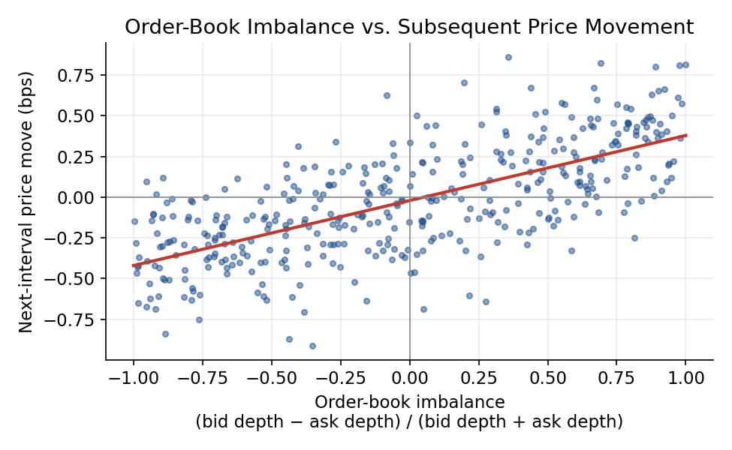
Figure 3.1 — Order-book imbalance plotted against the price move in the following short interval: a positive relationship exists on average, but with substantial scatter around it.
Common mistake — Treating every observed order-book imbalance as genuine directional information.
Displayed imbalance can reflect cancellable, non-committal liquidity, hidden or iceberg orders not reflected in the visible book at all, and order placement deliberately designed to mislead other participants. An imbalance signal that is not tested out-of-sample the way any other predictive signal would be is exactly the overfitting trap the curriculum's Model Validation module exists to catch — applied here to a microstructure signal instead of a longer-horizon forecasting model.

Part 4 — Execution Algorithms and Benchmarks
Once a trade's expected costs are understood, the practical question becomes how to actually work an order: how fast, in what sizes, against what benchmark. This part covers the standard execution benchmarks, the algorithms built to hit them, and the auction mechanisms many venues use at the open and close.

4.1 VWAP and TWAP
The volume-weighted average price (VWAP) of a security over a period is the average of all trade prices, weighted by the size of each trade — it is the price a participant trading proportionally to everyone else's activity would, by construction, achieve. The time-weighted average price (TWAP) instead samples price at even time intervals, ignoring how much volume actually traded at each point. A VWAP execution algorithm tries to track the market's own, typically U-shaped, intraday volume curve (heavier at the open and close, lighter mid-day), trading more when the market is trading more; a TWAP algorithm simply slices the order into equal pieces spread evenly across the execution window, regardless of the market's volume pattern.
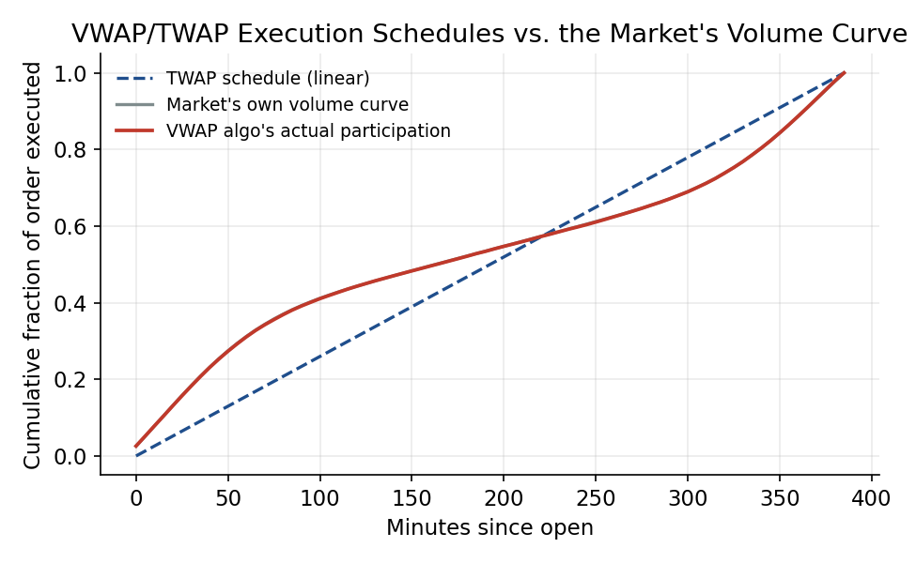
Figure 4.1 — A linear TWAP schedule trades at a constant rate regardless of market activity; a VWAP-tracking algorithm instead follows the market's own U-shaped volume curve, trading faster when the market itself is more active.
Worked example — Measuring performance against a VWAP benchmark.
An algorithm executes a 50,000-share buy order at an average price of $75.03, while the security's VWAP over the same execution window was $75.05. The order beat its benchmark by 2 cents per share, or roughly $1,000 — a standard way of reporting execution quality that is meaningful only once the benchmark itself (VWAP, TWAP, arrival price, or the closing price) has been clearly specified, since a strategy can look very different relative to different benchmarks.

4.2 Execution Algorithms and Optimal Execution
VWAP and TWAP are only two members of a broader family of execution algorithms. A percentage-of-volume (POV) algorithm targets trading a fixed fraction of whatever volume the market is currently doing, speeding up or slowing down with market activity. An implementation-shortfall algorithm optimises directly against the decision-price benchmark introduced in Part 2, explicitly trading off expected market impact against the price risk of trading too slowly. The Almgren-Chriss framework formalises this trade-off: trading faster reduces exposure to adverse price moves during execution (timing risk) but increases market-impact cost; trading slower reduces impact cost but increases timing risk, and an optimal execution trajectory balances the two according to the trader's risk aversion.
Prerequisite gate — Almgren-Chriss and optimal execution trajectories are Depth 3+ implementation detail.
At this level, the goal is to understand the shape of the trade-off — faster execution lowers price risk but raises impact cost, slower execution does the reverse — not to derive the closed-form optimal trading trajectory that balances them for a given risk-aversion parameter. That derivation, and its practical calibration, belongs to Depth 3+.

# Illustrative sketch of the Almgren-Chriss trade-off (not a full solver)
# total_cost = impact_cost(trajectory) + risk_aversion * timing_risk(trajectory)
for candidate_speed in trading_speeds: # slow → fast
impact = estimate_impact(candidate_speed) # rises with speed
timing_risk = estimate_price_risk(candidate_speed) # falls with speed
total_cost = impact + risk_aversion * timing_risk
record(candidate_speed, total_cost)
optimal_speed = candidate_with_lowest(total_cost) # balances impact vs. timing risk

4.3 Auction Mechanisms
Not all trading is continuous. Most exchanges open and close each session with a call auction: rather than matching orders continuously as they arrive, the exchange collects orders over a short window and computes a single clearing price that maximises the volume that can be matched, executing every matched order at that one price. Exchanges typically publish an indicative imbalance (how much more buy than sell interest, or vice versa, is currently in the auction) in the minutes leading up to the auction, letting participants adjust their orders before the final match. Closing auctions in particular concentrate a large share of a day's liquidity, partly because index funds and other benchmark-tracking strategies are contractually required to trade at the official closing price.

Part 5 — High-Frequency Trading and Market Quality
The very fastest participants in a market are simultaneously providers of liquidity and consumers of any latency edge available. This part covers what high-frequency trading actually does, why latency became a competitive battleground, and the resulting noise that the fastest layer of price data carries.

5.1 High-Frequency Trading
High-frequency trading (HFT) is not a single strategy but a set of technology-enabled approaches that share extremely short holding periods and heavy reliance on speed. Common categories include electronic market making (continuously quoting both sides of the book and earning the spread while managing inventory risk), statistical arbitrage (trading small, fleeting pricing discrepancies across related instruments), and latency arbitrage (reacting to a price change on one venue faster than other participants can update their orders on another). The overall effect of HFT on market quality is genuinely debated: HFT market makers are widely credited with tighter spreads and higher displayed liquidity in normal conditions, but critics point to episodes where that liquidity withdraws rapidly under stress, and to latency arbitrage as, in effect, a toll extracted from slower participants without adding proportional economic value. Both views appear in the empirical microstructure literature, and the balance of evidence varies by market and period.

5.2 Latency and the Race to Zero
Latency is the time delay between an event occurring in a market and a participant being able to observe it and react. Because being even microseconds faster than a competitor can determine who captures a fleeting arbitrage opportunity or who reaches the front of a queue, firms have invested heavily in reducing it: co-locating servers physically inside exchange data centres, building dedicated microwave and laser links between trading hubs (faster than fibre-optic cable over long distances), and executing logic directly on specialised hardware (FPGAs) rather than general-purpose software.
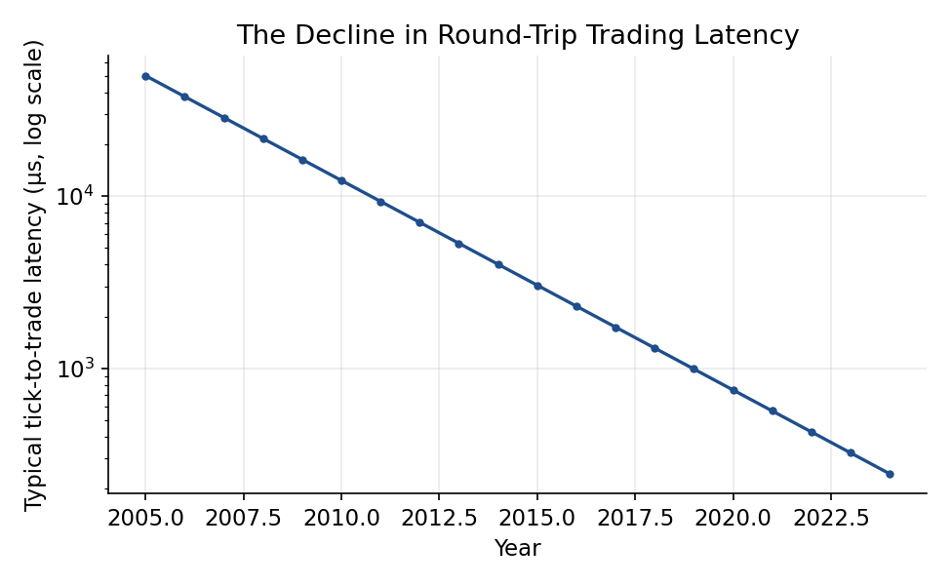
Figure 5.1 — The decline in typical round-trip (tick-to-trade) latency over roughly two decades, driven by co-location, dedicated network links, and specialised execution hardware.
Common mistake — Assuming latency doesn't matter for a slower strategy.
Even a strategy with a multi-day holding period is not exempt: it still submits and potentially cancels orders in the same market as HFT participants, and can suffer adverse selection or poor fills at the moment of order placement if it ignores how much faster information travels to other participants at that instant.

5.3 Microstructure Noise
Microstructure noise refers to the deviation of observed transaction prices from an underlying, unobservable "efficient" price, arising from sources such as price discreteness (minimum tick sizes), bid-ask bounce (trades alternating between the bid and ask even with no change in the efficient price), and other trading frictions. This noise means that price data sampled at very high frequency is not simply a more detailed version of lower-frequency data — it is dominated, at the shortest horizons, by noise rather than signal.
Tip — Sampling less often can produce a cleaner signal.
Because microstructure noise dominates at very short horizons, estimators such as realised volatility often perform better when computed from prices sampled every few minutes rather than every tick. This is a counterintuitive but well-documented result worth remembering before assuming that more granular data is always better data.

Part 6 — From Signal to Executable Strategy
This closing part draws the module's threads together: how the frictions covered in Parts 1 through 5 combine to determine whether a signal is actually tradeable, and what infrastructure a research or trading team needs to manage execution as an ongoing discipline rather than a one-time backtest assumption.

6.1 Translating a Signal Into a Realistic Trade
A strategy's capacity is the amount of size it can trade before its own market impact erodes the edge it is trying to capture — a signal worth 5 basis points per trade is worthless once trading it in the size required consumes more than 5 basis points in impact and spread cost. A signal's Sharpe ratio or expected return must therefore always be evaluated net of realistic execution costs, not gross, and the same look-ahead-bias discipline the curriculum's Model Validation module applies to features and labels applies equally to execution assumptions: assuming a fill at the day's closing price without checking whether the order size was realistic relative to actual closing-auction volume is its own quiet form of look-ahead bias.
Worked example — A rough capacity estimate.
A signal is expected to generate 8 basis points of edge per trade. Empirically, market impact for this security scales as roughly 10 basis points per √(participation rate), where participation rate is the trade's size as a fraction of average daily volume. Setting 10·√p = 8 gives a breakeven participation rate of about 64% of average daily volume — in practice, a much lower ceiling would be used to leave a safety margin, since the 8-basis-point edge estimate itself carries uncertainty and other costs (spread, slippage) have not yet been subtracted.

6.2 Building and Monitoring Execution Infrastructure
Transaction-cost analysis (TCA) is the practice of measuring realised execution cost, after the fact, against a chosen benchmark — arrival price, VWAP, or the closing price — to determine whether an execution algorithm and its parameters are performing as expected. Ongoing TCA closes the loop between research and trading: it feeds realistic, measured cost estimates back into signal research and strategy sizing, rather than leaving execution as a one-time assumption baked into an old backtest. This connects directly to the Development module, since accurate TCA depends on the same disciplined event-sequencing and data quality that market-data and execution systems must provide, and to the Risk Metrics module, since execution cost is itself a risk to be measured, monitored, and controlled over time.

Practical Exercise
Build a limit-order-book simulator from historical Level 2 data. Calculate the bid-ask spread, mid-price, market depth and order-book imbalance through time. Simulate market and limit orders at different sizes, measure execution price, slippage and market impact, then compare VWAP, TWAP and passive execution approaches.

Suggested approach
- Reconstruct the limit order book from raw Level 2 updates, maintaining correct time ordering, and compute the best bid/ask, mid-price, spread, depth, and order-book imbalance at each update.
- Simulate market orders of varying sizes against the reconstructed book, recording the realised execution price and the resulting slippage and market impact relative to the pre-trade mid-price.
- Simulate resting limit orders at several price levels, tracking queue position explicitly, and estimate the probability of a fill within a given horizon as a function of that queue position.
- Implement simple VWAP, TWAP, and purely passive (limit-order-only) execution strategies for a parent order, and compare their realised average execution price against the VWAP benchmark for that period.
- Produce a short transaction-cost analysis (TCA) report summarising slippage, market impact, and benchmark performance across order sizes and execution strategies.
# Skeleton for the practical exercise
book = LimitOrderBook()
for event in level2_events: # correctly time-ordered
book.apply(event)
metrics.record(
mid=book.mid_price(),
spread=book.spread(),
depth=book.depth(levels=5),
imbalance=book.imbalance(levels=5),
)

# Simulate execution strategies against the same reconstructed book
for strategy in [market_order, vwap_algo, twap_algo, passive_limit]:
fills = strategy.execute(parent_order, book_replay)
tca.append(evaluate_vs_benchmark(fills, benchmark="VWAP"))

Common Beginner Mistakes
- Treating the mid-price, or the last traded price, as an executable price.
- Ignoring the bid-ask spread and transaction costs when evaluating short-horizon strategies.
- Assuming displayed order-book liquidity will remain available at the moment an order actually attempts to trade.
- Ignoring queue position and the probability of receiving a fill on a resting limit order.
- Treating every observed order-book imbalance as genuine directional information, without considering cancellations, hidden liquidity, and strategic order placement.
- Using trade or quote data with incorrect timestamp ordering, producing unrealistic execution results.
- Assuming historical Level 2 data provides a complete representation of all liquidity actually available at the time.
- Backtesting execution strategies using closing prices or OHLC data when the strategy's performance actually depends on intraday order-book conditions.
- Evaluating a signal's Sharpe ratio gross of realistic execution costs, rather than net of the spread, impact, and slippage it would actually incur.

Advanced Extensions
The following are Depth 3+ topics, introduced here only by name so you know what to look for when you reach them:
- Limit-order-book modelling and stochastic order-book models — mathematical frameworks that treat the evolution of the full order book, not just the best price, as the object of study.
- Hawkes processes — self-exciting point processes used to model the clustering of order arrivals and trades in time.
- Kyle's lambda and Glosten-Milgrom models — formal models linking order flow to price impact and to the equilibrium bid-ask spread under information asymmetry.
- Almgren-Chriss optimal execution — the closed-form trade-off between market impact and timing risk introduced at awareness level in Part 4.
- Optimal market making and inventory-risk models — frameworks (e.g., Avellaneda-Stoikov) for setting bid and ask quotes to manage inventory risk while earning the spread.
- Adverse-selection modelling and queue-reactive models — more detailed statistical models of how order-book dynamics respond to, and predict, informed trading.
- Latency arbitrage and hidden/iceberg liquidity — the practical mechanics and detection of speed-based arbitrage and non-displayed order types.
- Microstructure invariance — an empirical framework proposing that trading activity, volatility, and transaction costs scale together in predictable ways across very different securities.
- Market fragmentation and smart order routing (Level 5) — how trading in a single security splits across many competing venues, and the algorithms built to route orders intelligently across them.

Professional Applications
- Algorithmic execution — designing and operating VWAP, TWAP, POV, and implementation-shortfall algorithms for institutional order flow.
- Market making — continuously quoting both sides of the book and managing the resulting inventory and adverse-selection risk.
- High-frequency trading and statistical arbitrage — exploiting short-lived pricing discrepancies and speed advantages across venues and related instruments.
- OTC pricing and liquidity management — quoting and managing risk in markets that trade off-exchange, without a centralised, visible order book.
- Transaction-cost analysis and execution analytics — measuring realised trading costs against benchmarks and feeding the results back into strategy and algorithm design.
- Smart order routing and electronic trading infrastructure — building and maintaining the systems that route, manage, and monitor orders across a fragmented market in real time.
- Market-impact estimation — building the empirical models that predict trading cost as a function of order size, used throughout the applications above.

Where to Go Next
This module deliberately stopped at awareness level for the harder quantitative machinery underlying microstructure: stochastic order-book models, Kyle's lambda and Glosten-Milgrom, Almgren-Chriss optimal execution, and the full range of Advanced Extensions above. Depth 3+ of this same module returns to each of them quantitatively, with explicit derivations, implementation of optimal execution trajectories, and calibration exercises against real order-book data, and is the appropriate next stop before attempting to design or operate production execution or market-making systems. From there, the curriculum's Research module depends on this material for order-flow and liquidity signals, and the Risk Metrics and Optimisation modules depend on it for realistic, cost-aware position sizing and portfolio construction.

